Assignment-35.3:

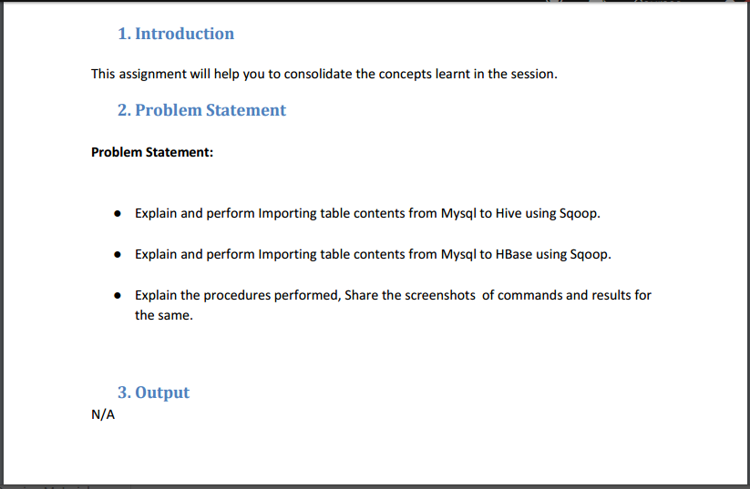

Explain and perform Importing table contents from Mysql to Hive using Sqoop

Creating a table named sample and inserting the values into the table:

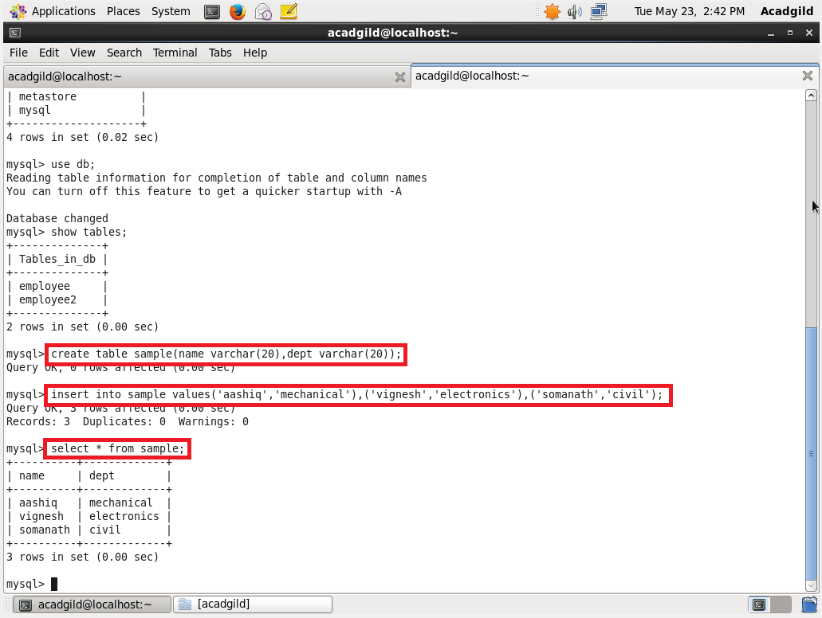

Importing the data from mysql to hive using the below command:

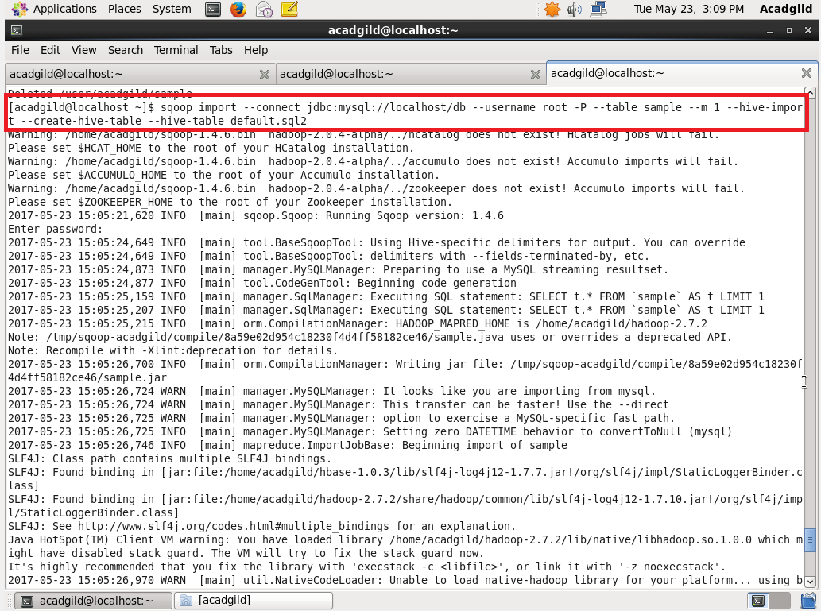

The data is loaded into the table sql2:

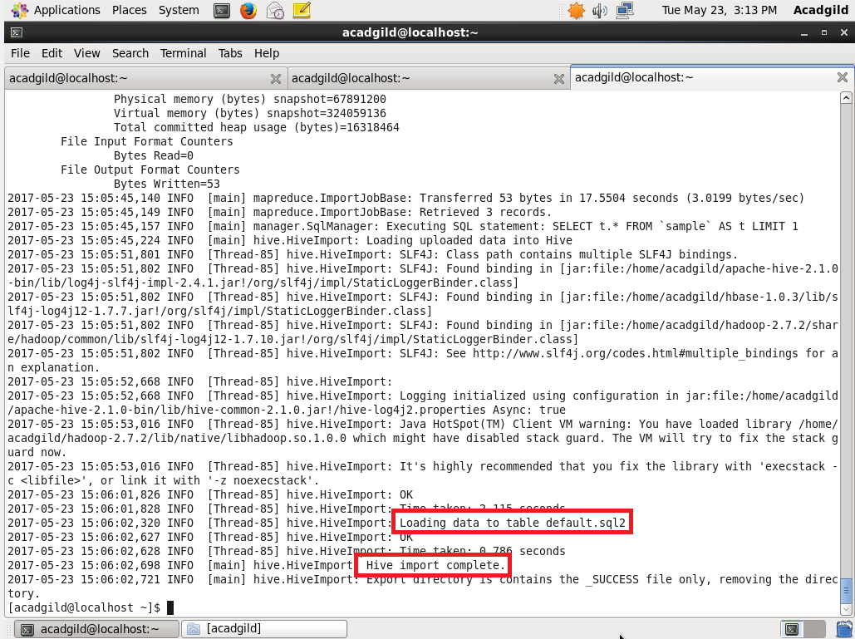

The data from mysql is imported into the hive

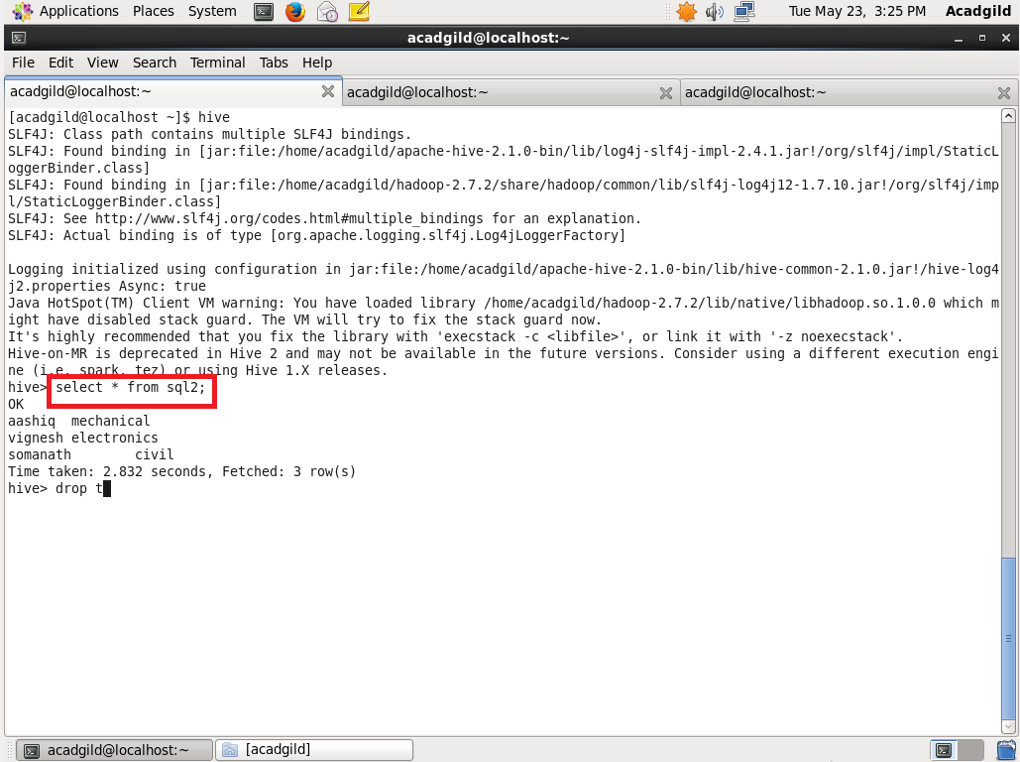

Explain and perform Importing table contents from Mysql to HBase using Sqoop

Creating a table named sql in hbase:

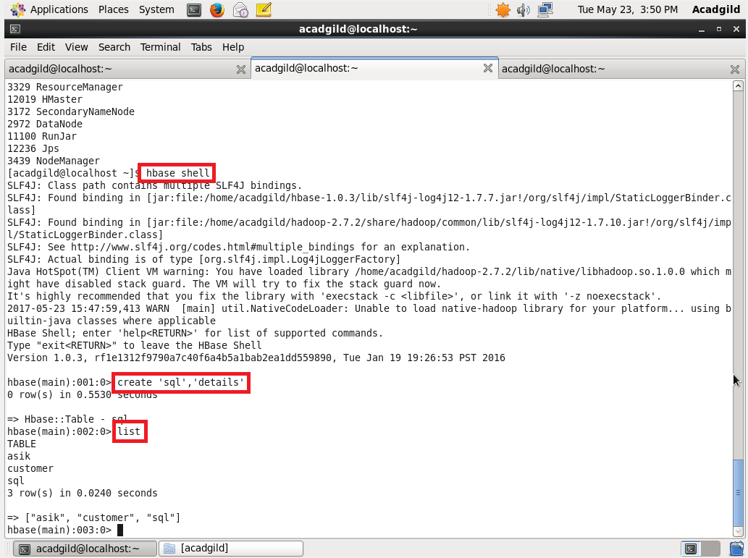

Importing the data from mysql to hbase using the below command:

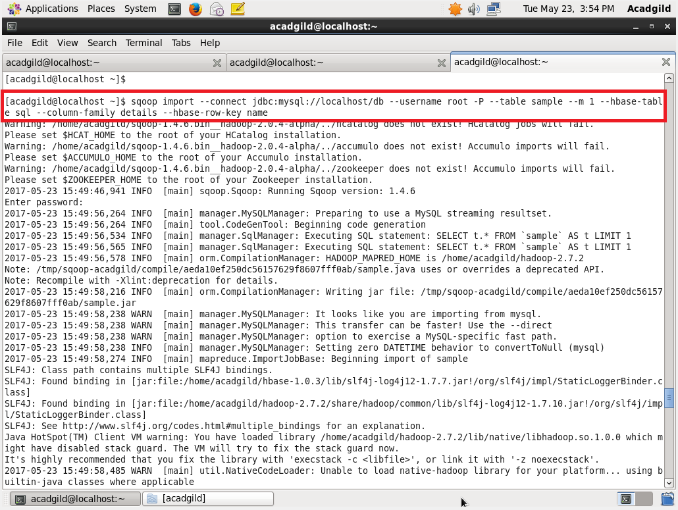

The table is successfully imported to hbase:

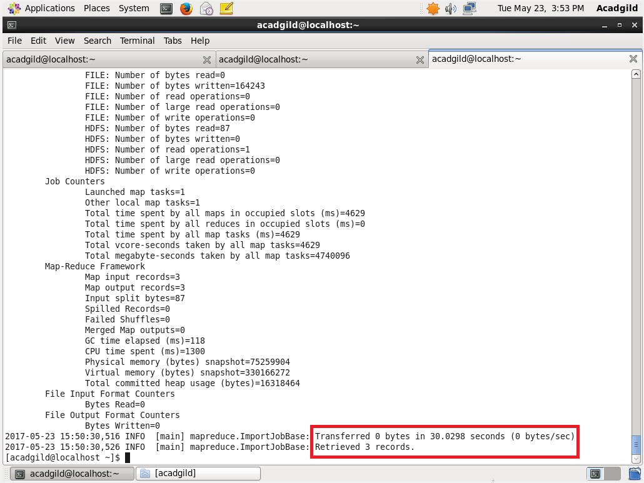

The contents of the table is displayed using scan command:

